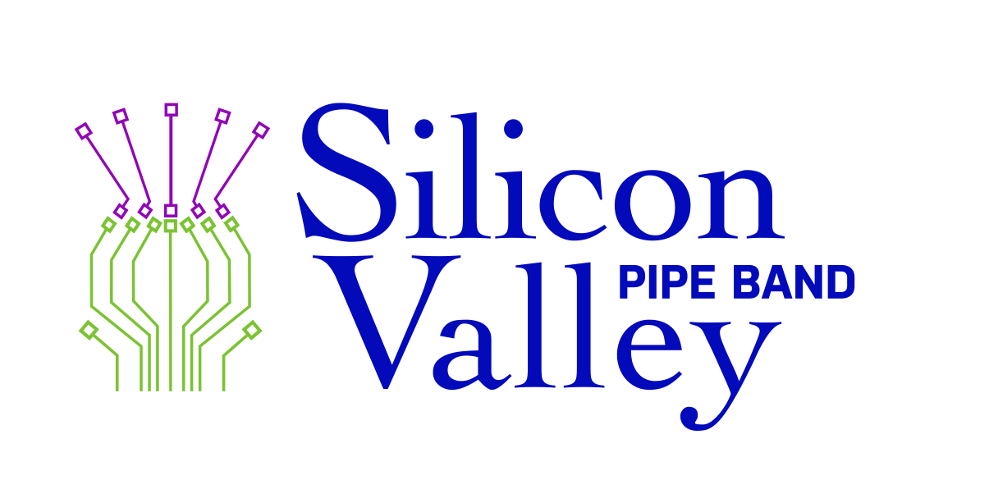
103 Cardinal Lane, Los Gatos, CA 95032
www.siliconvalleypipeband.org

August 14, 2019

POTENTIAL DONOR
ADDRESS
CITY, ST ZIP

Dear (POTENTIAL DONOR);

Silicon Valley Pipe Band is a 501 (c) (3) non-profit organization created to educate the public in piping, drumming, dance, and other art forms associated with Scottish and Celtic culture. We perform both publicly and privately, and instruct those interested in bagpiping and Scottish drumming. We offer parade, concert, and competition bands. Our culture is one of continual technical improvement coupled with a familial environment.

Each fall, Silicon Valley Pipe Band hosts an educational piping and drumming workshop for anyone seeking to further enhance their musical skills. We invite renowned pipers and drummers to instruct our intensive two-day workshop. This year our workshop will be held Saturday, November 2nd – Sunday, November 3rd.

Your donation of (REQUESTED ITEM) from (POTENTIAL DONOR) will serve as a prize for either a raffle drawing, silent auction, or incentive giveaways for our participants. To make your contribution more visible we are pleased to recognize you in our welcome letter as a supporter of our event. Contributions are tax-deductible as allowed by law. Our tax id number is EIN 02-0593433.

Your consideration is very much appreciated. Should you have any questions, please feel free to contact me at (ENTER CONTACT INFORMATION).

Sincerely,

NAME
Piper/Drummer, Silicon Valley Pipe Band

